Video Lesson PoC – Roadmap v2
Oct 21, 2026 · @Pauli
The PoC turns Teams recordings into text lessons, audio lessons and narrated slide videos, fully on the project laptop; animated characters are the next phase. NotebookLM runs alongside as a second route on the same knowledge. This is the plan as we see it today; it will be adjusted as tests on real recordings come in.
Input: Teams recordings with slides (clean slide videos and live sessions), audio files and their transcripts. Screen demos (e.g. Excel) and the folder of XML, XSD and image files are out of scope for now.

Capability map
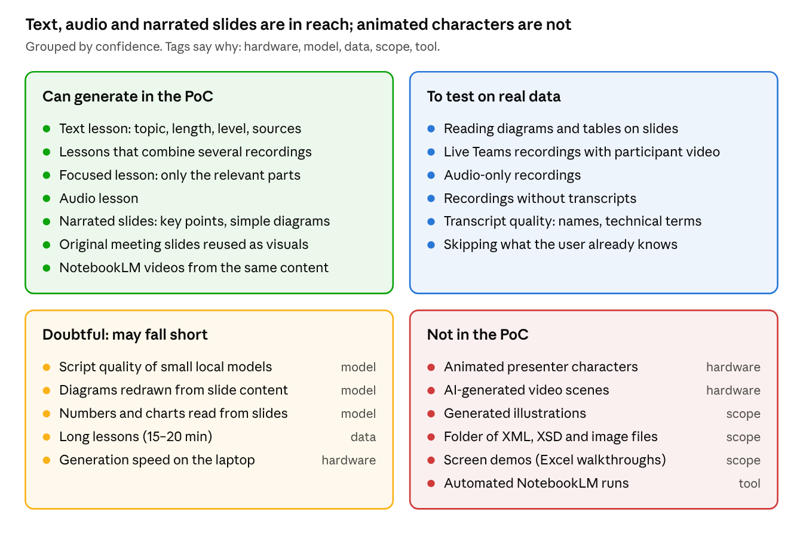
capability map · 4 groups by confidence
Tags say why an item is limited: hardware (no graphics processor on the laptop), model (small local models), data (depends on what the recordings contain), scope (left out of the PoC on purpose), tool (limits of NotebookLM's free version). Items move up as real recordings go through the pipeline.

Why the limited items sit where they do
Item | Why | What would change it
Script quality of small local models | Small models on a laptop write plainer, more repetitive scripts than large cloud models | A newer local model, or a large model on the cloud platform
Diagrams redrawn from slide content | Small models may miss arrows, order or labels on a slide | A larger model on the cloud platform
Numbers and charts read from slides | Small models often misread figures | A larger model on the cloud platform
Long lessons (15–20 min) | A lesson can't hold more than the recordings say about a topic, and long videos are slow to make | More recordings on the topic
Generation speed on the laptop | Without a graphics processor, even a short video takes several minutes | Cloud models
Animated presenter characters | AI video needs a graphics processor; hand-drawn characters take long to build | Paid video or avatar services
AI-generated video scenes | Even a strong graphics card needs over 4 minutes per 5-second clip; in the cloud it costs about $1.50 per second | A budget of about $1,800 per 20-minute video
Generated illustrations | Possible on the laptop, but slow and generic; the fastest free models are for research use only | Cloud image models
Folder of XML, XSD and image files | Left out to focus on recordings; it may hold course packages with real text | Checking what the files are
Screen demos (Excel walkthroughs) | Constantly changing screens don't split into slides | A later phase
Automated NotebookLM runs | The free version has no programming interface | NotebookLM Enterprise

What users can ask for
Examples use topics from the recordings.
Request (example) | In the PoC | NotebookLM | After the PoC, with cloud services
"Explain the Power BI workflow, from data sources to sharing. 5 minutes, beginner." | Yes: text lesson with links to the source meetings | Yes | Better writing
"I already know Power BI basics. Only the data model part, 3 minutes." | Yes, to test: only the relevant parts | Partly, through instructions | Better at judging what to skip
"Summarise what all sessions say about implementing GenAI." | Yes: one lesson from several recordings | Yes | Better writing
"A 5-minute audio lesson on the steps of a GenAI project." | Yes | Yes | More natural voices
"8 narrated slides on the GenAI architecture, intermediate level." | Yes: key points, simple diagrams, original slides | Yes, in several visual styles | Richer layouts and visuals
"Narrated slides with an illustration on each slide, whiteboard style." | Not yet: illustrations come after the PoC | Yes, whiteboard and other styles | Yes, with cloud image models
"A 20-minute course from all Power BI sessions." | Limited by what the recordings cover; may take long to generate | No control over exact length | Faster; same content limit
"An animated presenter explains the Power BI workflow." | No | Closest: its story-style video | Possible with paid video or avatar services, at a high cost
Every answer depends on the topic being covered in the recordings; if it isn't, the system says so instead of guessing.

Tools and models
In the PoC: free tools on the project laptop
Tool | What it does
Qwen 2.5 language model (via Ollama) | Writes lessons and scripts; the newer Qwen3.5 will be tested
Qwen vision model | Reads diagrams and tables on slides
Search model (Nomic) | Finds the right content for a topic
Kokoro | Voice for audio lessons and videos
Whisper | Transcripts for recordings without one
Tesseract and FFmpeg | Read slide text; cut and assemble video
NotebookLM (now Gemini Notebook) | Narrated videos from the same content, as a quality benchmark
NotebookLM makes polished videos in ready visual styles, but each one is made by hand, can take over 30 minutes, and the free plan allows 3 videos a day.
After the PoC: paid services
Option | What it adds
Large language models on the cloud platform (e.g. Claude on Amazon Bedrock) | Better lessons and scripts, much faster
Cloud voices (Amazon Polly) | More natural voices
Cloud image models (Stability AI on Amazon Bedrock) | Illustrations and sketches for slides
Cloud video models (Luma Ray2 on Amazon Bedrock) | Short AI video scenes, up to 9 seconds each; expensive at length
Avatar video services | Animated presenters; need approval and licences
NotebookLM Enterprise | Partial automation, so far for audio only
Image and video models on Amazon Bedrock currently run only in the US West region, which needs checking against data rules.
Ideas for after the PoC: generated illustrations, slide styles chosen by the user, diagrams that build up while they are explained, animated presenters, and the folder of XML, XSD and image files.

Limitations
- Laptop only: without a graphics processor, a short video takes several minutes to make, and AI-generated video is not possible.
- Small local models: lessons and scripts are plainer than with large cloud models, and numbers on slides can be misread.
- Content: only what the recordings say. A lesson can't be longer or deeper than its sources, and every lesson links back to them.
- Costs: measured on the laptop and priced at cloud rates, so the estimate is approximate.

Plan to the demo
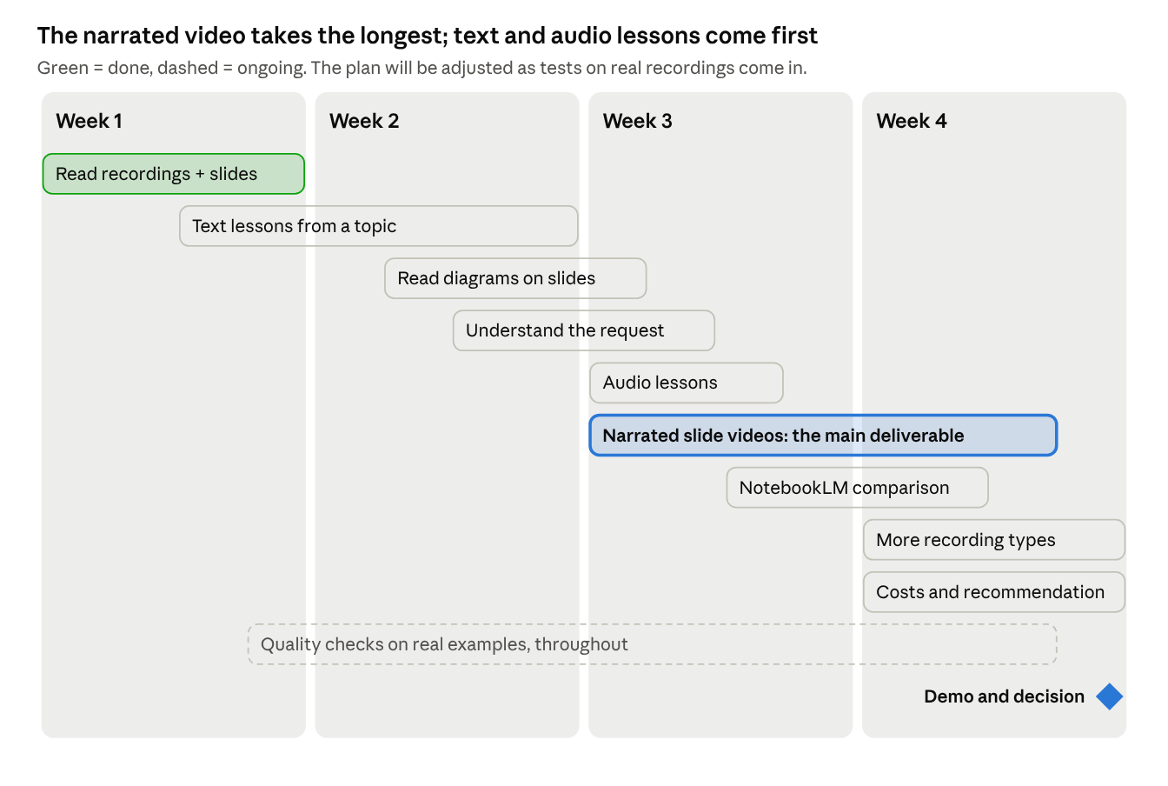
plan to the demo · 4 weeks, 3 gates
Steps in order; each builds on the one before.
- Set up the laptop and access. Done.
- Read the recordings and their slides: transcripts split into short passages, slide text extracted. Done.
- Find the right content for a topic across all recordings.
- Write text lessons for a chosen topic, length and level, with links to the source meetings.
- Check quality on a fixed set of real example requests, and again after every change.
- Read diagrams and tables on slides, not just their words.
- Understand a request written in plain words: topic, format, length and level.
- Produce audio lessons.
- Produce narrated slide videos: key points, simple diagrams and original slides, with a voice explaining them. This is the largest and riskiest step and may take longer.
- Make the same topics in NotebookLM and compare them with the local results.
- Add audio-only recordings, then recordings without transcripts.
- Estimate the cost of running this on the cloud platform and recommend next steps.
- Prepare and run the demo.

Sources
- Google: NotebookLM is now Gemini Notebook
- Google Help: Generate Video Overviews
- Gemini Notebook limits by plan
- NotebookLM supported file types
- Google Cloud: NotebookLM Enterprise audio overview API
- FastSD CPU: image generation on a CPU
- Kokoro voice on a CPU
- Wan 2.1 video model hardware requirements
- Bedrock video models and prices
- Amazon Bedrock model catalog 2026
- Ollama: Qwen3.5

